Name: ______________________________

Date:_______________________________

OGT Prep Academy: Week 2

Key Terms for Biology & Earth Science

OGT Science: Biology (Life Science) Key Terms
1. ATP
- Code
- Energy
- Flagella
- Fusion

2. Cell division
- DNA
- Respiration
- Photosynthesis
- Mitosis

3. has a nucleus
- eukaryote
- prokaryote
- bacteria
- electron

4. Protective shield in the atmosphere... being eaten away by pollution (called CFC's).
- Ozone Layer
- Biodiversity
- Global Warming
- Acid Rain

5. Respiration
- Makes sugar and releases Oxygen
- For locomotion
- Stores code for living things
- Burns Sugar, releases Carbon Dioxide

6. Homozygous
- has the same genes
- Has different genes
- force that drives evolution
- Variety in genes in a population

7. Variety of Life Forms
- Acid Rain
- Global Warming
- Ozone Layer
- Biodiversity

8. Chloroplast
- Stores the DNA
- nucleus
- Photosynthesis
- Cell Membrane

9. Has no nucleus
- eukaryote
- prokaryote
- plant cell
- animal cell

10. Mitochondria
- Respiration
- DNA
- Photosynthesis
- Mitosis

11. Adaptation
- Biodiversity
- All living things living together
- Global Warming
- Changing to fit the surroundings and survive better.

12. A eukaryote
- you
- prokaryote
- an electron
- bacteria

13. Natural selection
- Force that drives Evolution
- All living things living together
- Changing to fit the surroundings and survive better.
- Slow change in Life forms over time

14. Cilia and Flagella
- Stores code for living things
- Burns Sugar, releases Carbon Dioxide
- Makes sugar and releases Oxygen
- For locomotion

15. Nucleus
- Cell Membrane
- Vacuole
- Ribosome
- Stores the DNA

16. mitochondria
- nucleus
- Photosynthesis
- Respiration
- Stores the DNA

17. Nucleus
- DNA
- Photosynthesis
- Mitosis
- Respiration

18. Photosynthesis
- Makes sugar and releases Oxygen
- Burns Sugar, releases Carbon Dioxide
- Stores code for living things
- For locomotion

19. DNA
- Makes sugar and releases Oxygen
- Stores code for living things
- Burns Sugar, releases Carbon Dioxide
- For locomotion

20. Evolution
- Force that drives Evolution
- Slow change in Life forms over time
- site of respiration
- All living things living together

21. Heterozygous
- force that drives evolution
- Variety in genes in a population
- Has different genes
- has the same genes

22. Genetic Variation
- Variety in genes in a population
- has the same genes
- Mitochondria
- force that drives evolution

23. Cell division that makes Reproductive Cells (eggs or sperm cells)
- meiosis
- cloning
- genetic engineering
- mitosis

24. Ecosystem
- Slow change in Life forms over time
- All living things living together
- Changing to fit the surroundings and survive better.
- Force that drives Evolution

25. eukaryote
- who care eyote
- a cell with flagella
- cell without organelles
- cell with organelles

Answers
1. B
2. D
3. A
4. A
5. D
6. A
7. D
8. C
9. B
10. A
11. D
12. A
13. A
14. D
15. D
16. C
17. A
18. A
19. B
20. B
21. C
22. A
23. A
24. B
25. D

Explanations
1. During Respiration, sugar is burned and the energy is stored in ATP.
2. Mitosis is regular cell division... it copies its DNA and splits into 2 cells. Meiosis is cell division which reduces the amount of DNA in half... it is for making reproductive cells.
5. Respiration happens in the mitochondria... it burns sugar and consumes Oxygen. it stores the energy in ATP and releases Carbon Dioxide.
6. A person with 2 of the same genes for a trait. Dominant genes are shown as capital letters, and Recessive genes are shown as lower case letters. Dominant genes cover up Recessive genes. like RR would be homozygous, because it has 2 dominant genes. rr is also homozygous because it has 2 recessive genes.
7. Having a large diversity of living things keeps ecosystems working together effectively. we lose biodiversity when an animal species go extinct (are completely wiped out) visit... http://www.eoearth.org/article/Biodiversity?topic=49480
8. Chloroplasts are organelles perform Photosynthesis... they make sugar and release Oxygen.
10. Mitochondria are organelles inside cells which perform Respiration... they burn sugar and release Carbon Dioxide. They store the energy from sugar into ATP molecules.
13. Natural selection is like "survival of the fittest"... What is the most successful and reproduces the most will survive. check out... http://evolution.berkeley.edu/evolibrary/article/evo_25
14. cilia and flagella help microscopic life move around (locomotion = moving around) check out this video... http://www.dnatube.com/video/5967/flagella--cilia
15. A Nucleus is an Organelle which contains the DNA. DNA stores the code for living things.
16.
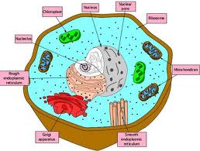

Mitochondria are organelles inside cells which perform Respiration... they burn sugar and release Carbon Dioxide. They store the energy from sugar into ATP molecules.

17. the Nucleus is an organelle which stores the DNA.
18. Photosynthesis is what plants do when they capture the suns energy and lock that into sugar and release energy.
19. DNA stores the code for all living things... everybody has different DNA (except Ientical twins), that's why everybody is a little different. for further learning,... http://www.dnai.org/
20. Science believe all life came from the same ancestors, and has slowly changed over ver about 3.5 billion years... from bacteria, to plants, to dinosaurs, to caveman. for further learning... http://evolution.berkeley.edu/evolibrary/article/evo_01
21. A person with 2 different genes for a trait. Dominant genes are shown as capital letters, and Recessive genes are shown as lower case letters. Dominant genes cover up Recessive genes. like Rr would be heterozygous, because it has one dominant and one recessive gene.
22. some populations have a lot of variety in their genes, like humans. some types of animals do not have a lot of variety of genes... they are all genetically similar... this is bad because if something kills one of them, it could kill all of them. A population with high genetic variation can more easily adapt to situations. http://evolution.berkeley.edu/evolibrary/article/evo_17
24. an ecosystem is all living things living together and how they are all connected... a plants produce material and bring in energy from the sun, animals consume the plants (herbivores), and then animals consume the animals (carnivores/ predators). Everything is interconnected, including all humans (what did you eat today?... where does food come from?) for further learning... http://www.nhptv.org/NatureWorks/nwepecosystems.htm

OGT Earth and Space Science Key Terms
1. Cracking/ fracture of plates.
- Faulting
- condensation
- Nuclear Fusion
- Folding

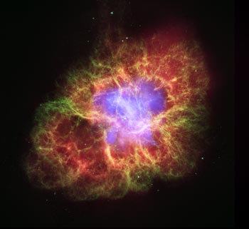
2. What is this?
- a Nebula
- the Big Bang
- a Spiral Galaxy
- a Solar System

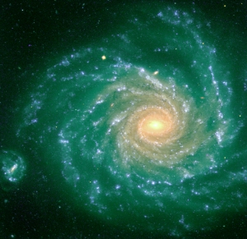
3. What is this?
- A spiral Galaxy
- The Big Bang
- a Solar System
- a Nebula

4. The study of weather
- Archaeology
- Astronomy
- Plate Tectonics
- Meteorology

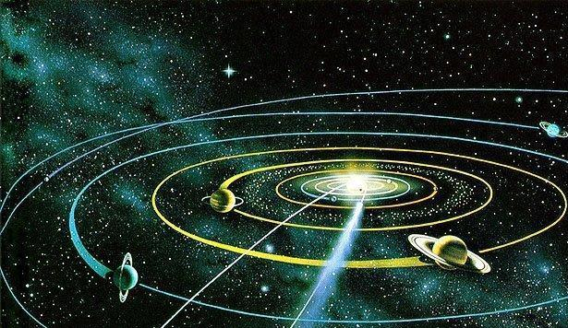
5. What is this?
- the Big Bang
- a Nebula
- a Solar System
- A Spiral Galaxy

6. Age of the universe
- about 14.5 billion years
- about 7000 years
- about one million years
- 2011 years

7. The study of the Earths crust
- Plate Tectonics
- Meteorology
- Astronomy
- Archaeology

8. Measuring the age of rocks or fossils by measuring the radioactive materials in them.
- Radiometric Dating
- Relative Dating
- Blind Dating
- Rockageolology

9. Name the surface layer of the Earth.
- Crust
- Nebula
- Core
- Magma

10. When atoms are smashed together
- Nuclear fusion
- Nuclear fission
- photosynthesis
- Oxidation

11. The crust is broken into pieces called Lithospheric…
- Plates
- Flagella
- Magma
- Nebula

12. When Lithospheric Plates move and smash against each other
- Tsunamis
- Hurricane
- earthquakes
- volcanoes

13. The fact that the same fossils are found in the same rock layers on each continent.
- Relative Dating
- Radiometric Dating
- Fossil Correlation
- Absolute Dating

14. When plates smash together and crush upward…
- Tsunami
- Hurricane
- Volcanoes
- Mountains

15. When atoms split apart.
- Meiosis
- mitosis
- Nuclear fission
- Nuclear fusion

16. Magma flows in circular patterns called&
- Mitochondria
- Convection currents
- Chloroplasts
- Plate tectonics

17. The source of all life energy…
- Nuclear fission
- Stem cells
- The sun
- Covalent bonds

18. When comparing the age of rock layers...
- Top layer is oldest
- Oldest is youngest (…what?)
- Deepest is oldest
- Deepest is youngest

19. Main force in the universe …
- Nuclear fission
- Nuclear fusion
- photosynthesis
- gravity

20. Earth's Plates were once all locked together into one giant continent called…
- Mothra
- Pangea
- Supernova
- Giganto-continus

21. Center of the earth solid Iron
- Core
- Nucleus
- Nebula
- Pangea

22. Bending of plates.
- Folding
- condensation
- Faulting
- Nuclear Fusion

23. A huge cloud of gas and dust in space…
- Nebula
- Constellation
- Neutron
- Proton

24. When Magma is forced though faults in the plates crust.
- Tsunamis
- volcanoes
- Hurricane
- earthquakes

25. Measuring the age of rocks or fossils by comparing them to the things around them.
- Radiometric Dating
- Double Dating
- Blind Dating
- Relative Dating

Answers
1. A
2. A
3. A
4. D
5. C
6. A
7. A
8. A
9. A
10. A
11. A
12. C
13. C
14. D
15. C
16. B
17. C
18. C
19. D
20. B
21. A
22. A
23. A
24. B
25. D

