Name: __________________________________
Date: ___________________________________
Earth Science A & B: Assorted Ecology Topics
Biotic & Abiotic Parts of Environments:
The living things within an environment are called biotic factors, while the non-living things are called abiotic factors. The animals, plants, fungi, and microscopic forms of life that share the same environment are all examples of biotic parts. The soil, water, air, light, heat, minerals, rocks, and weather are all examples of abiotic parts of the environment.

Example 1: Which of these is a biotic part of a desert environment?
sand sun tarantula dew
Answer: The tarantula. Sand, sun, and dew are important parts of the desert environment, but they are not living things. The tarantula is the only living thing, so it is the biotic part.
Example 2: Which biotic part of an environment relies upon soil to get nutrients?
tree spider bird fish
Answer: The tree. Trees are plants that need nutrients from the soil to make food. Spiders, birds, and fish need to eat plants or other animals to get the nutrients they need. The tree is the biotic part that relies upon soil for nutrients.

Land Biomes
Vocabulary in this section includes-

Biome:
Tundra:
Permafrost:
Deciduous Forest:
Desert:
Nocturnal:
Savanna (Grassland):
Chaparral (Scrubland):
Wetland:
Tropical Rain Forest:
Equator:
Canopy:

On earth there are areas that share the same climate and soil conditions, as well as plant and animal life. These areas are called biomes. There are seven major land biomes: tundra, deciduous forest, desert, grassland (savanna), chaparral (scrubland), wetland, and tropical rain forest.
The tundra biome is a treeless, cold area, located in the Arctic Circle. The tundra is treeless because it does not receive enough of the sun's energy to allow for large plants to produce their own food. The plants that live in the tundra are lichens, mosses, and grasses which grow right along the ground, and have very small leaves. Just below the surface of the tundra, the soil stays frozen year-round which inhibits deep root development in plants. This layer of soil is called permafrost. Polar bears and brown bears use the tundra for hunting fish and small rodents. Birds, moose, caribou, and insects migrate to the tundra during warmer summer months to feed and reproduce.
Deciduous forests are located in areas that experience cold winters, warm springs and summers, with seasonal sunlight and rainfall. The plant life in the deciduous forest includes trees, shrubs, and other plants that can live in shadows cast by trees. During fall, the leaves on the trees in deciduous forests change colors, and the trees lose their leaves by winter. Lichens, mosses, and fungi also live in deciduous forests. Because of the abundance of plant life, a variety of animals inhabit the forest. Black and brown bears, deer, rodents, birds, insects, spiders, cats, foxes, wolves, caribou, moose, as well as some amphibians and reptiles, can make their homes there finding plenty of food, water, and shelter.
The desert is a biome that receives very little to no rainfall. Plants in the desert must be well adapted to the harsh temperatures and lack of moisture to survive. In hot deserts, the majority of plants are cacti and grasses, which have special stems for storing water. The animals in deserts must be able to live off of these specialized plants as well as deal with the lack of moisture and extreme temperatures. Certain lizards, tortoises, snakes, rodents, insects, birds, and spiders can live well in a desert. Most of the animals in a desert biome are nocturnal, which means they are mostly active at night when the temperatures are cooler.
The grassland, also called the savanna, is a biome with few or no trees. The primary plant life consists of grasses which depend upon streams, seasonal rainfall, and plenty of sunlight to meet their needs. The wide-open space of the grassland is attractive to migrating and herding animals such as buffalo, horses, deer, antelope, and cattle. Ducks, geese, songbirds, hawks, and falcons, can live in grasslands depending on the amount of water and food that exist there. Larger animals such as foxes, wolves, lions, cheetahs, and hyenas migrate to the grassland as long as there is plentiful prey and enough shelter. Small rodents, reptiles, insects, and amphibians find grasslands ideal for feeding on plants.
Chaparral, sometimes called scrubland, is a biome located in coastal areas where the climate is moderate, but the environment can be harsh. Rainfall is not predictable, and these areas can experience flooding at times. Winds are strong and the soil is loose and sandy. Plants have adapted to the chaparral by limiting their height, and their leaves tend to be small and dense. Small birds, reptiles, insects, and some rodents live in the chaparral biome. Larger animals migrate there to feed, but the plant life is not ideal for sheltering their larger bodies.
A wetland is a biome that exists where fresh water sources from the land collect in a low lying area. A wetland is sometimes called a swamp or estuary. Many of the trees, grasses, mosses, and shrubs live directly in the water. They may have root systems that grow into the muddy and sandy bottom of the wetland, or may simply float in the water, trailing their roots underneath or beside them. Like the plants, the animals in a wetland spend most of their lives in the water. Alligators, crocodiles, snakes, lizards, amphibians, insects, and birds have adaptations that allow them to move, find shelter, and feed easily in this watery environment. Insects of many kinds find the wetland attractive because of the mild climate and large amount of water. Some rodents make their homes in wetlands, while many fish live in the waters.
The tropical rain forest is the biome with the most diversity in plant and animal life. Tropical rain forests circle the globe, at the equator, on all continents. Near the equator, the temperature is always warm. There is always plenty of sunlight, and much rainfall. Plants with wide, glossy, green leaves thrive in a hot, humid environment (climate). Trees of great height create a canopy, or roof-like covering, over the top of the forest with their branches and leaves. Sometimes this canopy is so thick that no sunlight reaches the forest floor. The layers of plant life in the rain forest learn to adapt to the amount of sunlight they receive, and grow strong from the abundance of nutrients in the soil. The variety of plant life in the rain forest is equaled only by the diversity of animal life. In no other biome can so many animals - insects, birds, reptiles, amphibians, arachnids, rodents, apes, monkeys, cats, bears, boars, bats and humans - live together and have their needs met.
Energy Pyramid
Vocabulary in this section-

Energy Pyramid:
Trophic Level:
Producers:
Consumers:
Primary Consumer:
Secondary Consumer:
Scavenger:

The energy pyramid is a model that shows the relationships between trophic levels in an environment and the amount of energy that is passed from organism to organism. A trophic level is a group of organisms performing a specific role in an environment. The trophic levels are producers, primary and secondary consumers, and scavengers. Producers are plants; they make their own food from the sun. A consumer is an organism that cannot make its own food, so it feeds on plants or other animals. Primary consumers eat only producers and secondary consumers eat other consumers. A scavenger is a secondary consumer that feeds on dead or decaying organisms.

Here are some examples of the interactions between these trophic levels:
- A sparrow (secondary consumer) eats a seed (producer).
- A vulture (scavenger) eats a dead lion (secondary consumer).
- An owl (secondary consumer) eats a mouse (primary consumer).
- A mouse (primary consumer) eats grass (producer).

An energy pyramid shows most of these relationships in pyramid form. Producers are on the bottom of the energy pyramid. They get all of their energy from the sun. The next level is the primary consumers. They get their energy from eating the producers, but there is less energy at this level because some energy was lost in the exchange as heat. Secondary consumers get energy from eating primary consumers. There is the least amount of energy at the top level of the pyramid because energy is lost in each exchange. As you can see in the following diagram, the higher you go in the pyramid, the less the amount of energy.
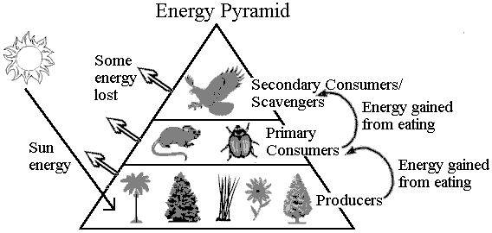

Populations
Vocabulary in this section includes-
Biotic Factors:
Abiotic Factors:
Population:
Limiting Factors:
Biotic Potential:
Carrying Capacity:
Sustainability:

- Living things in an environment, such as trees and animals, are called biotic factors.
- Non-living parts of an environment, such as amount of sunlight, climate, soil, and cleanliness of the air, are called abiotic factors.
- A population is a group of the same type of organism in an ecosystem. Populations increase and decrease in number based on the birth rates as well as how long organisms survive.

A limiting factor is a specific biotic or abiotic factor that stops a population from increasing. Sometimes an area has plenty of water, space, and clean soil, but there are not enough mice for the owls to eat. The lack of food may be the limiting factor for the owl population, because without food, fewer owls will survive and the population will decrease. After a few seasons, the mouse population may increase because there are fewer owls to kill them. The mouse population could reach its biotic potential, where the conditions of the environment are just right for the maximum capacity of mice to survive and reproduce. If too many mice are present though, the population may reach carrying capacity.
The carrying capacity is the maximum population size that an ecosystem can support before food, water, shelter, or space begin to run out. These shortages will eventually affect reproduction and survival, and therefore limit the population. Sustainability is the ability to maintain, support, or provide for something. An environment reaches sustainability when there are enough resources, space, and diversity so that the needs of all organisms are being met. Sustainability in an environment is important because it means an environment can allow many different organisms to survive for a long time. Without sustainability in an environment, population numbers fluctuate greatly or carrying capacity is reached quickly.
Example: Eagles eat fish. If the lake in the eagles' habitat becomes extremely polluted, how will the eagle population be affected?
A. The eagle population will increase.
B. The eagle population will decrease.
C. The eagle population will stay the same.
D. The eagle population will reach their biotic potential.
Answer: B. If the lake is extremely polluted, the fish that live there will die. Since the lake is in the eagles' habitat and is where they get fish, the eagles will not have enough food. This will decrease the eagle population.
Material Cycles
Vocabulary in this section includes-

Material Cycle:
Water Cycle:
Evaporation:
Condensation:
Precipitation:
Groundwater:
Transpiration:

In this section, you will learn about how materials in the environment, such as water, nitrogen, carbon, and oxygen, are distributed, replenished, and cycled. You will also understand the impact of environmental changes on the material cycles. One example of a material cycle is the water cycle. Water from oceans and lakes is heated by the sun and turns into water vapor, a gas, in a process called evaporation. The vapor enters the atmosphere, cools, and turns into droplets, called condensation. Condensation is what forms clouds.
The clouds move over land and release snow, hail, or rain, called precipitation. As the water falls to earth, several things can happen. Some of the water runs off the land into streams or rivers, or it seeps into the soil to become groundwater. Groundwater is water that is found underground in spaces between soil particles or rocks. The streams and rivers eventually empty water back into lakes or oceans. Water can also seep into the ground where plants absorb and use it. As water is used by plants, it reenters the atmosphere through transpiration, a process where plants give off water vapor. As water evaporates, the process repeats itself.
The following is an illustration of the water cycle:
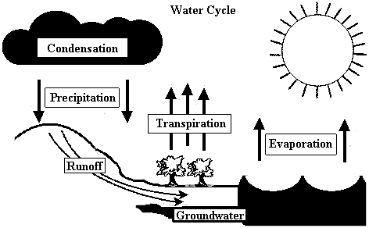
The Nitrogen Cycle
Vocabulary in this section includes-

Nitrogen:
Nitrogen Cycle:
Nitrogen-Fixing Bacteria:
Nitrates:
Photosynthesis:

All living things need nitrogen to live. Though our atmosphere is about 78% nitrogen, it is not in a form useable to many organisms. In the nitrogen cycle, nitrogen gas in the air is converted to useable nitrogen. This process begins with bacteria in the soil and on the roots of plants. These bacteria, called nitrogen-fixing bacteria, use the nitrogen in the air and convert it to nitrates in the soil. Nitrates are nitrogen compounds that can be used by plants. Plants absorb the nitrates from the soil to use in photosynthesis, a process by which plants make their own food.
Animals get the nitrogen they need from the plants that they eat. When plants and animals die or produce waste, decomposers in the soil break down the material and convert it to nitrates. Some of the nitrates are broken down further by other bacteria, which release nitrogen gas back into the atmosphere.
The following is an illustration of the nitrogen cycle:
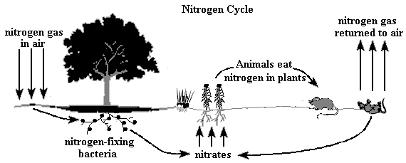
The Carbon & Oxygen Cycles
Vocabulary in this section includes-

Carbon:
Oxygen:
Carbon Cycle:
Oxygen Cycle:
Respiration:

The carbon and oxygen cycles work together because both elements are combined in our air as carbon dioxide. The carbon from carbon dioxide is used by plants in photosynthesis, and oxygen is given off during the process. Oxygen is used by animals and plants in respiration, or breathing, and carbon dioxide is released. Respiration is the process where the cells exchange gasses with the environment. Like nitrogen, carbon is also stored in plant tissues, which are then eaten by animals. After organisms die, their decomposed tissues release carbon dioxide into the atmosphere.
The following is an illustration of the carbon and oxygen cycle:
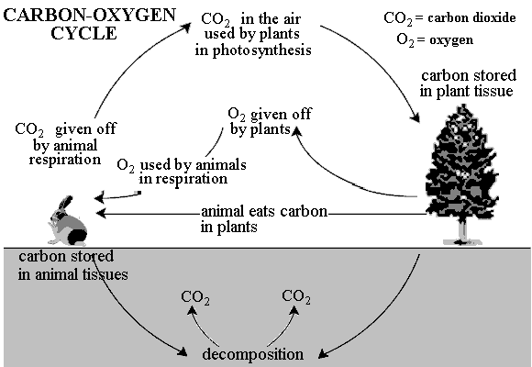
Any change that affects the materials involved in these cycles can in turn affect the environment in some way. For instance, if all of the plants in an area were removed due to clear cutting or development, the water cycle would be affected. Transpiration, an integral part of the water cycle, would not take place in that area. The nitrogen cycle would be affected because there would be no plant roots to convert nitrogen in the air to useable nitrogen in the soil. Also, animals in the area would not have plants to eat in order to obtain the nitrogen they need. Finally, the carbon and oxygen cycle would be disrupted in that area. If there are no photosynthesizing plants, there is no source of oxygen production.
Organism Interactions
Vocabulary in this section includes-

Symbiosis:
Symbiotic Relationships:
Mutualism:
Parasitism:
Commensalism:
Cooperation:
Predation:
Competition:

Organisms in a habitat interact constantly. Sometimes these interactions are helpful to a particular organism, sometimes they are harmful, and sometimes the organism is not affected at all, but these interactions are all an important part of keeping an ecosystem functioning. When two organisms of a different species interact with each other it is called symbiosis. There are three types of symbiotic relationships: mutualism, parasitism, and commensalism.
Mutualism is a relationship that benefits both organisms involved. Birds sit on the backs of water buffalo and eat insects off of them. This allows the birds to get food, and protects the water buffalo from getting insect bites. When one organism benefits from a relationship but the other organism is harmed, it is called parasitism. Mistletoe is a parasitic plant because it grows on a tree and takes the tree's water and nutrients. Eventually, the tree may weaken and die because it doesn't get enough water and nutrients. Commensalism is when one organism benefits from the relationship while the other organism is not affected. Remora are fish that attach themselves to the fins of sharks. This is good for the remora because they get food scraps from the shark and they get carried through the ocean, but they don't affect the shark at all.
Cooperation can occur in ecosystems when two or more organisms of possibly the same species act in order to get benefits from one another. For example, fish swim together in schools to protect themselves against predators. Another way organisms interact is through competition. Since many organisms may have the same needs and there may only be a limited amount of material in the ecosystem, they must compete for food, water, shelter, or space. Both organisms are adversely affected. Acts of predation, when a predator hunts prey, sometimes bring about competition among organisms. An example of this is when a lion catches and eats an antelope. Many other lions, or scavengers like hyenas and vultures, will try to eat the same antelope that was killed by the lion.
Example: A leech attaches itself to a human to drink his blood. What type of relationship is this?
A. mutualism
B. commensalism
C. cooperative
D. parasitism
Answer: D. This is a parasitic relationship because the leech benefits by getting food, but the human is harmed because the leech is taking valuable blood away from the human.

