Earth Science A & B: Astronomy
A star is a massive, luminous sphere of plasma held together by gravity. The nearest star to Earth is the Sun, which is the source of most of the energy on the planet. Some other stars are visible from Earth during the night when they are not obscured by atmospheric phenomena, appearing as a mass of fixed luminous points because of their immense distance. Historically, the most prominent stars on the celestial sphere were grouped together into constellations and asterisms, and the brightest and largest stars have gained proper names. Extensive catalogues of stars have been assembled by astronomers, which provide standardized star designations.
For at least a portion of its life, a star shines due to thermonuclear fusion of hydrogen into helium in its core, releasing energy that traverses the star's interior and then radiates into outer space. Almost all naturally occurring elements heavier than helium are created by stars, either via stellar nucleosynthesis during their lifetimes or by supernova nucleosynthesis when very massive stars explode. Near the end of its life, a star can also contain a proportion of degenerate matter. Astronomers can determine the mass, age, chemical composition and many other properties of a star by observing its spectrum, luminosity and motion through space. The total mass of a star is the principal determinant in its evolution and eventual fate. Other characteristics of a star are determined by its evolutionary history, including diameter, rotation, movement and temperature. A plot of the temperature of many stars against their luminosities, known as a Hertzsprung–Russell diagram (H–R diagram), allows the age and evolutionary state of a star to be determined.
A star begins as a collapsing cloud of material composed primarily of hydrogen, along with helium and trace amounts of heavier elements. Once the stellar core is sufficiently dense, hydrogen becomes steadily converted into helium through nuclear fusion, releasing energy in the process.^{[1]} The remainder of the star's interior carries energy away from the core through a combination of radiative and convective processes. The star's internal pressure prevents it from collapsing further under its own gravity. Once the hydrogen fuel at the core is exhausted, a star with at least 0.4 times the mass of the Sun^{[2]} expands to become a red giant, in some cases fusing heavier elements at the core or in shells around the core. The star then evolves into a degenerate form, recycling a portion of its matter into the interstellar environment, where it will form a new generation of stars with a higher proportion of heavy elements.^{[3]} Meanwhile, the core becomes a stellar remnant: a white dwarf, a neutron star, or (if it is sufficiently massive) a black hole.
Binary and multi-star systems consist of two or more stars that are gravitationally bound, and generally move around each other in stable orbits. When two such stars have a relatively close orbit, their gravitational interaction can have a significant impact on their evolution. Stars can form part of a much larger gravitationally bound structure, such as a cluster or a galaxy.
Main Sequence Star Formation:
Stars spend about 90% of their lifetime fusing hydrogen to produce helium in high-temperature and high-pressure reactions near the core. Such stars are said to be on the main sequence and are called dwarf stars. Starting at zero-age main sequence, the proportion of helium in a star's core will steadily increase. As a consequence, in order to maintain the required rate of nuclear fusion at the core, the star will slowly increase in temperature and luminosity–the Sun, for example, is estimated to have increased in luminosity by about 40% since it reached the main sequence 4.6 billion (4.6 × 10⁹) years ago.
Every star generates a stellar wind of particles that causes a continual outflow of gas into space. For most stars, the amount of mass lost is negligible. The Sun loses 10⁻¹⁴ solar masses every year, or about 0.01% of its total mass over its entire lifespan. However, very massive stars can lose 10⁻⁷ to 10⁻⁵ solar masses each year, significantly affecting their evolution. Stars that begin with more than 50 solar masses can lose over half their total mass while they remain on the main sequence.
The duration that a star spends on the main sequence depends primarily on the amount of fuel it has to fuse and the rate at which it fuses that fuel, i.e. its initial mass and its luminosity. For the Sun, this is estimated to be about 10¹⁰ years. Large stars consume their fuel very rapidly and are short-lived. Small stars (called red dwarfs) consume their fuel very slowly and last tens to hundreds of billions of years. At the end of their lives, they simply become dimmer and dimmer.^{[2]} However, since the lifespan of such stars is greater than the current age of the universe (13.7 billion years), no stars under about 85% of solar mass,^{[65]} including all red dwarfs, are expected to have moved off of the main sequence.
Besides mass, the portion of elements heavier than helium can play a significant role in the evolution of stars. In astronomy all elements heavier than helium are considered a "metal", and the chemical concentration of these elements is called the metallicity. The metallicity can influence the duration that a star will burn its fuel, control the formation of magnetic fields^{[66]} and modify the strength of the stellar wind.^{[67]} Older, population II stars have substantially less metallicity than the younger, population I stars due to the composition of the molecular clouds from which they formed. (Over time these clouds become increasingly enriched in heavier elements as older stars die and shed portions of their atmospheres). Refer to the diagram below:
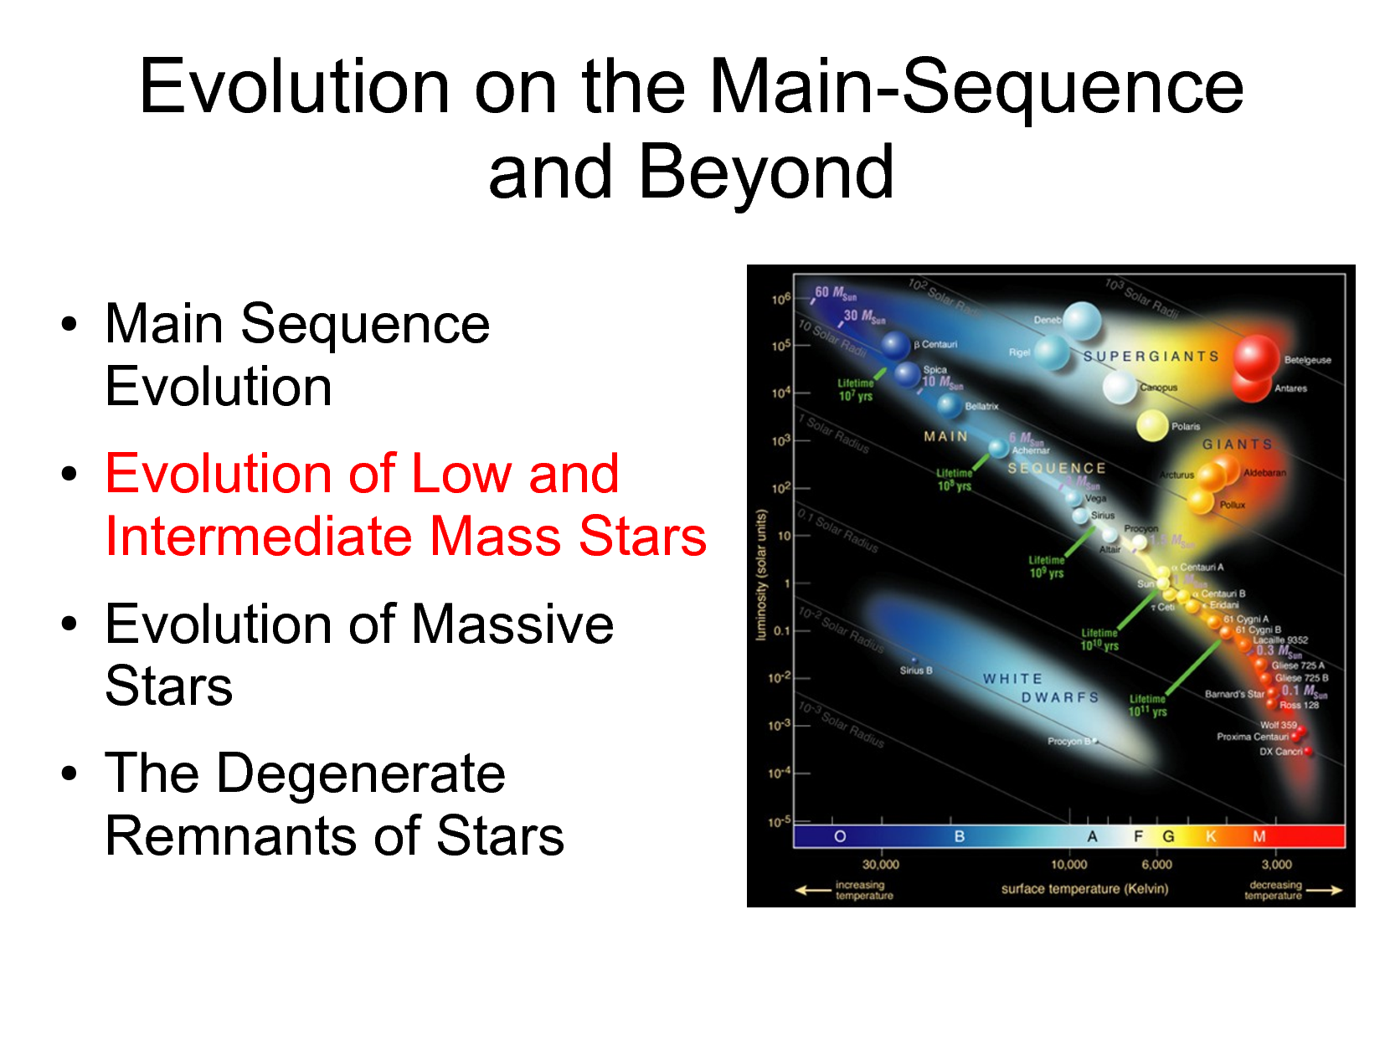

Prostars:
The formation of a star begins with gravitational instability within a molecular cloud, caused by regions of higher density often triggered by shock waves from supernovae (massive stellar explosions), the collision of different molecular clouds, or the collision of galaxies (as in a starburst galaxy). Once a region reaches a sufficient density of matter to satisfy the criteria for Jeans instability, it begins to collapse under its own gravitational force.
As the cloud collapses, individual conglomerations of dense dust and gas form what are known as Bok globules. As a globule collapses and the density increases, the gravitational energy is converted into heat and the temperature rises. When the protostellar cloud has approximately reached the stable condition of hydrostatic equilibrium, a protostar forms (at the core). These pre–main sequence stars are often surrounded by a protoplanetary disk. The period of gravitational contraction lasts for about 10–15 million years.
The graph below shows Temperature (T) compared to Lumosity (AKA: Brightness)~
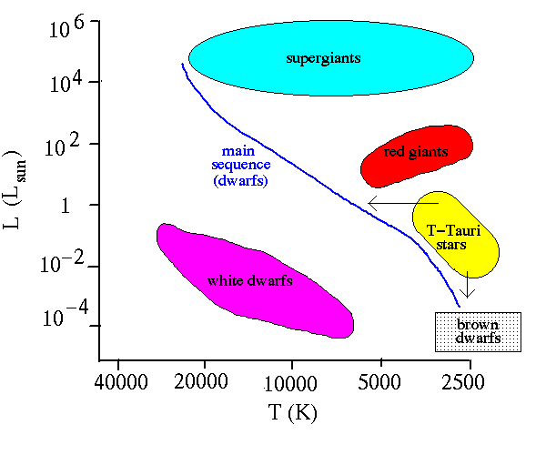
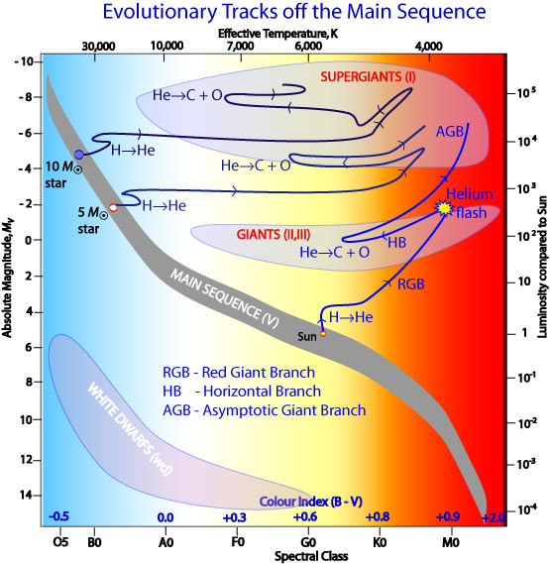

This Picture shows Main Sequence Stars and the fusion of Hydrogen into Helium:
