Name: ______________________________________

Date: _______________________________________

Biology A & B: Study Guide
Review: Organelles, Intro to Genetics, Cell Division (Mitosis & Meiosis), Fertilization through Birth, Taxonomy (Classification of Living Things), Infection
New Material: Nervous System

Review: Organelles (Cell Parts)~
Vocabulary in this section includes-

Nucleus:
Cytoplasm:
Cell Membrane:
Cell Wall:
Chloroplasts:
Lysosomes:
Vacuoles:
Mitochondria:
Nucleolus:
Golgi Body:
Ribosomes:
Endoplasmic Reticulum (ER):
Smooth & Rough Endoplasmic Reticulum:
Thylakoids:
Nuclear Membrane:

- The cell membrane is the layer that surrounds the cell, protects it, and allows some materials to pass in and out of the cell.
- The cell wall is an extra layer on the outside of plant cells that is rigid to give the plant support and prevent loss of moisture.
- The cytoplasm is a thick jelly-like substance inside the cell in which all of the organelles are suspended.
- The nucleus is an organelle on the inside of the cell that controls the functions of the cell and contains genetic material.
- Chloroplasts contain green pigments, called chlorophyll, and are the organelles in plants where photosynthesis, a process where plants make food using the sun's energy, occurs.
- Vacuoles are used for the storage of water, food, or wastes inside the cell.
- Lysosomes contain enzymes and digest materials inside the cell.
- Ribosomes make proteins.
- The nucleolus is located inside the nucleus and produces ribosomes.
- The golgi body packages materials and secretes them outside the cell or to other locations within the cell.
- Mitochondria conduct chemical reactions that provide the cell with energy.
- The endoplasmic reticulum, or ER, is a membrane network found throughout the cytoplasm. It extends from the nucleus to the cell membrane and transports materials around the cell. Rough ER contains ribosomes and Smooth ER does not.
- The nuclear membrane surrounds the nucleus and is porous to allow some materials to pass through.
- Thylakoids are flat, stacked structures inside the chloroplasts that contain chlorophyll.

Organelles (Cell Parts) Continued- The following diagram shows the cell parts, or organelles:
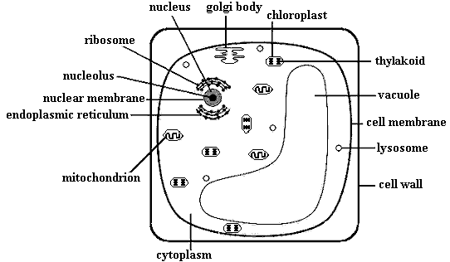

Genetics
Vocabulary for this section includes:
Traits:
Dominant:
Recessive:
Linked Genes:
Co-Dominance:
Punnett Square:
Genotype:
Phenotype:
Di-Hybrid Cross:
Allele:
Polygenic Trait:
Incomplete Dominance:
Linked Genes:
Sex-Linked Genes:

Individual inherited characteristics, or traits, may be dominant or recessive. In most cases, dominant traits are expressed if they are present and recessive traits are only expressed if the dominant trait is not present. Capital letters are used to express dominant traits and lowercase letters are used for recessive traits. These letters are called alleles. For example, if you are looking at the gene for the ability to roll your tongue, an "R" may represent the dominant trait of the ability to roll your tongue and an "r" would represent the recessive trait of not being able to roll your tongue. An individual will have a pair of these alleles such as Rr, RR, or rr, representing his or her genotype (actual genes that an individual has in their genetic code).
If the genotype has a dominant allele in it, the individual will express the dominant form of the trait. People with a genotype of Rr or RR will be able to roll their tongue. If only recessive alleles are present, the trait is recessive. A person with a genotype of rr will not be able to roll his or her tongue. The actual trait or characteristic that is expressed (visible features) is called the phenotype.
Alleles and genotypes are used to find the probability that an offspring will express a certain trait. They are placed in a chart called a Punnet square. The alleles on the outside of the following Punnet square are from the parents' genotypes for tongue rolling and the four different genotypes on the inside represent the possible genotypic combinations for each offspring. The top of the Punnet square is labeled with one parent's genotype, and the side is labeled with the other parent's genotype. In the top left square, the "R" from the mother and the first "R" from the father combine to form RR. The top right square is RR because the "R" from the mother and the second "R" from the father combine. The bottom left square is Rr because the "r" from the mother and the first "R" from the father combine. The bottom right square is Rr because the "r" from the mother and the second "R" from the father combine.
When the alleles for a single trait are the same, as in RR or rr, it is said to be homozygous. When the alleles are different, Rr for example, it is heterozygous. In the following Punnet square, the probability of having offspring with a homozygous genotype of RR is 50% and having offspring with the heterozygous genotype of Rr is also 50%, though all four genotypes will show the same dominant phenotype. In other words, all offspring will be able to roll their tongues.
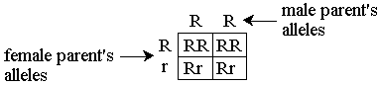
Usually, each trait in a specific gene is controlled by one allele that is dominant over another. This is not always the case. Co-dominance is when two alleles in a genotype are both fully expressed in the phenotype and show no dominance over each other. An example of co-dominance is a blood type of AB. Both the "A" allele and the "B" allele are equally dominant so both are fully expressed. Incomplete dominance is when two alleles mix to form a phenotype that is a combination of the two traits. Certain plants that have an allele for white flowers and an allele for red flowers will create pink flowers. Some traits are controlled by interactions between more than one pair of genes. These are called polygenic traits and may occur in traits like skin color. Skin color in humans is determined by five separate genes, with two alleles each. A person can have many different combinations of these alleles resulting in various skin colors.
Linked genes are located on the same chromosome, so they will be inherited together. Sex-linked genes are carried on the X or Y chromosomes, which are the chromosomes that determine sex. Colorblindness is a sex-linked trait. It is much more common for males to be colorblind because the gene for that trait, which is recessive, is carried on the X chromosome. Women have two X chromosomes, so if they carry the colorblindness gene on one X chromosome, it could be masked by the other X chromosome. Men only have one X chromosome, so if they carry the gene, there is nothing to mask it. For instance, blood type is an example of co-dominance and colorblindness is an example of a sex-linked trait.

Since organisms have more than one trait, a di-hybrid cross is used to predict different combinations of genotypes. A di-hybrid cross works like a simple Punnet square, but contains a larger chart. The alleles for seed texture and color in pea plants are as follows:
R = round seed
r = wrinkled seed
Y = yellow seed
y = green seed
The following is an example of a di-hybrid cross for seed color and texture in pea plants:
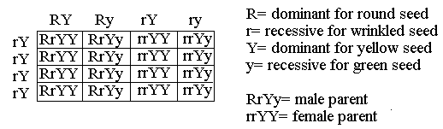
The male parent has a genotype of RrYy. One allele is for texture, one is for color, and there are only four combinations of the allele pairs. The headings on the chart break this genotype into RY, Ry, rY, and ry. For the female parent with a genotype of rrYY, the four combinations are rY. The allele pairs on the outside of the squares are combined in each square to make a four-allele genotype. The male parent is heterozygous for round, yellow seeds and the female is homozygous for wrinkled, yellow seeds. The probability of an offspring with a genotype of RrYY is 4/16 (or 1/4) because there are four of these genotypes out of the 16 possibilities or squares. There is a 8/16 (or 1/8) chance of having a wrinkled yellow seed offspring. They have a genotype of rrYY or rrYy.
Example: Using a di-hybrid cross, find the probability of beetles having an offspring with red eyes and long wings. Red eyes are dominant, black eyes are recessive, long wings are dominant and short wings are recessive. The male parent, with red eyes and long wings, has a genotype of RrLl. The female parent, with red eyes and short wings, has a genotype of Rrll. Answer: 6:16 (or 3:8).
The genotypes that will produce a beetle with red eyes and long wings are RRLL, RrLl, RRLl, and RrLL. As you can see in the following di-hybrid cross, the genotypes RRLl and RrLl show up 6 times out of 16 possible squares. So the probability is 6:16 (or 3:8).
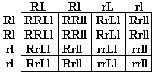
Cell Division: Mitosis and Meiosis~ Since this is for review, vocabulary terms are bolded for your convenience!
There are two cell division processes, mitosis and meiosis, where cells divide to produce more cells. To understand these processes, it is important to understand genes and chromosomes. Genes control heredity, the transfer of characteristics from parents to offspring, and determine the traits that will be expressed. Genes link together to form chromosomes. Chromosomes are structures that carry genes and come in pairs.
Mitosis is a form of asexual reproduction that is needed for the growth and repair of cells. It is a process by which a cell divides and passes on copies of its DNA to its daughter cells. The daughter cells are identical copies of the parent cell. Genetic material in the nucleus, a structure in the center of cells, must duplicate before the process begins. The four subsequent phases of mitosis are described here.
1. Prophase: Chromosomes shorten and become visible, then the nuclear membrane (the layer on the outside of the nucleus) begins to deteriorate. Long filaments that aid the movement of the chromosomes, called spindle fibers, appear. Also, small structures called centrioles move toward the opposite sides of the nucleus.
2. Metaphase: The chromosomes line up in the center of the cell. At this point, spindle fibers attach to the center of each chromosome.
3. Anaphase: The chromosomes separate in half, are pulled away from the center, and move to the opposite ends of the cell.
4. Telophase: The chromosomes lengthen, each group reaches one of the centrioles, and the spindle fibers disintegrate. Finally, the cell undergoes cytokinesis where the cell cleaves (divides), the cytoplasm (a thick jelly-like substance inside cells) splits in two, and two daughter cells are formed.
Mitosis Continued:
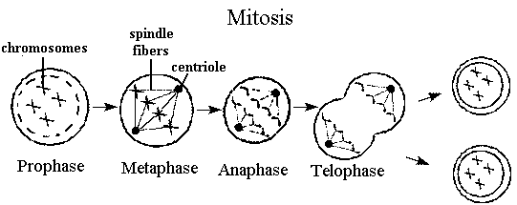
Meiosis~ Since this is for review, vocabulary terms are bolded for your convenience!
Meiosis is the process that produces sex cells. Unlike mitosis, the cells produced are not identical and contain only half the number of chromosomes as the original cell. Before meiosis begins, the genetic material in the cell must replicate. Meiosis occurs in two stages where two separate cell divisions occur. These two stages are called meiosis I and meiosis II. Each phase is similar to the phases of mitosis but are numbered with a I or II, depending when they occur. These phases are described here.
1. Prophase I: Chromosomes shorten and become visible, the nuclear membrane deteriorates, and spindle fibers appear. Chromosomes that are similar, called homologous chromosomes, pair up next to each other. Homologous chromosomes entangle so that their genes can be mixed in a process called cross over.
2. Metaphase I: The homologous chromosomes line up along the center of the cell and spindle fibers attach to them.
3. Anaphase I: The homologous chromosomes separate. These chromosomes move towards opposite sides of the cell.
4. Telophase I: In the final phase of meiosis I, the cell divides into two cells. Each of the two cells has one double stranded chromosome from each of the homologous chromosome pairs.
Before meiosis II begins, the chromosomes do not replicate. Each of the cells produced from meiosis I will divide from this point in prophase II, metaphase II, anaphase II, and telophase II. The processes in these final four phases are the same as in mitosis, though in meiosis, four different sex cells are formed from the one original cell.
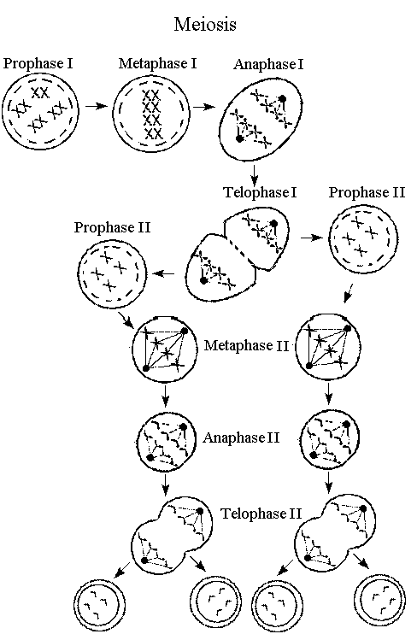
Fertilization through Birth:
Fertilization occurs when a sperm, the male sex cell, unites with an egg, the female sex cell. The fertilized egg is called a zygote. After fertilization, the zygote begins to divide rapidly into more and more cells as it is embedded in the uterine wall. An embryo is eventually the result of these cell divisions. After approximately three months, the embryo begins to show distinguishable human characteristics and is then called a fetus. Finally, when the fetus is fully developed, the baby is born. This entire process takes approximately 40 weeks.
During development, the fetus needs nourishment. The placenta is an organ in the mother that nourishes the fetus. The umbilical cord connects the fetus to the placenta. It allows nutrients and gases to pass from the placenta to the fetus while wastes pass from the fetus to the placenta. The fetus is suspended in amniotic fluid, which protects it. All of these structures are located inside of the mother's uterus. The following diagram shows the placenta, the umbilical cord, the wall of the uterus (uterine wall), and the amniotic fluid.
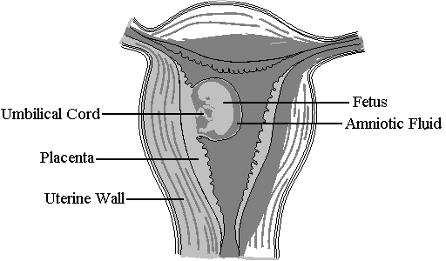

Taxonomy: The Classification of Living Things

Eukaryotic Organisms: are organisms with a nucleus in their cells (Examples include: Animals, plants, and fungi, like mushrooms).
Prokaryotic Organisms: are cells without a nucleus. (Example includes: Bacteria)
Autotrophic Organisms: Are able to make their own food using either energy from the sun through a process called photosynthesis, or using chemical energy. (Example: Plants)
Heterotrophic Organisms: cannot make their own food; they must get it from the outside environment or by decomposing dead organisms. (Examples: Animals & fungi)
The kingdoms Eubacteria and Archaebacteria contain organisms that are prokaryotes. Organisms in these two kingdoms were both formerly grouped into the same kingdom, called Monera. Eubacteria are single-celled organisms and are commonly called bacteria. Archaebacteria, also called archaea, are also single-celled organisms, but they live in extreme conditions, such as very hot or highly acidic environments. Both eubacteria and archae can be either autotrophic or heterotrophic. Autotrophic archae make energy from chemicals and heterotrophic archae obtain energy from food. Autotrophic eubacteria make energy from either sunlight or chemicals and heterotrophic eubacteria obtain energy from food.
Eubacteria and archaebacteria are also classified on the basis of environment and shape. For example, archaebacteria live only in harsh environments. There are three shapes of bacteria. Round bacteria are called cocci, rod shaped bacteria are bacilli, and spiral shaped bacteria are spirilla. Bacteria reproduce by binary fission or conjugation. Binary fission is the simple splitting of a cell in two. Conjugation is the transfer of genetic material through cell to cell contact.
Protists, sometimes called protoctists, are organisms from the kingdom Protista. They are eukaryotic. Most protists are unicellular and they are described as either plant-like, animal-like, or fungus-like. Algae, seaweeds, and euglenoids are plant-like protists. They contain chlorophyll, a green pigment that helps them photosynthesize, but they do not have true stems, roots, or leaves. Euglenas can move on their own, even though they are grouped in the plant-like protist category. Euglenas also have some characteristics of animal-like protists.
Protozoans are animal-like protists because they are heterotrophic, can move on their own, and are unicellular. They are classified into groups based on their structures for locomotion. Ciliates, like paramecium, move using cilia, small hair like structures that propel the organism. Flagellates, such as giardia, are propelled by whipping around their long tail-like filaments called flagella. Sarcodinians, such as amoebas, move with foot-like projections called pseudopods.
Fungus-like protists, like slime molds, have life cycles similar to fungi and live in damp, shaded areas. Slime molds contain plasmodium, a mass of cytoplasm, the jelly-like liquid inside cells that contains many nuclei.

Review: Viruses and Infection~ Since this is for review, vocabulary terms are bolded for your convenience!

Viruses are not included in any of the five kingdoms of organisms because they have some characteristics of living things and some characteristics of non-living things. Similar to living things, viruses can move, reproduce, and respond to their environment, but unlike living things, they are not composed of cells and cannot live or reproduce without a host cell. A host cell is a cell of another organism that a virus lives in or infects. Viruses are composed of nucleic acid, which is genetic material, in a protein capsid (coat), and sometimes have spikes protruding from the capsid. The following are illustrations of two different types of viruses. 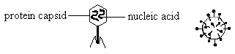
Though all viruses contain basically the same structures, they can have very different shapes. Viruses are classified by their shape, size, the type of genetic material they contain, and the type of organism they infect. Viruses that infect bacteria are called bacteriophages.
Viruses can reproduce in two ways, through the lytic cycle or the lysogenic cycle (also called lysogeny). The type of virus determines which cycle will occur. Both cycles begin with the virus attaching to a host cell. Next, the virus injects the host cell with nucleic acid, emptying its capsid. At this point, the two cycles begin to differ.
Viruses: The Lytic Cycle~
The host cell accepts the virus's nucleic acid instead of its own and then reproduces. New viruses form inside the cell, take over the cell, and burst out of the membrane, killing the cell. The new viruses spread to new cells and the lytic cycle begins again. The following is an illustration of the lytic cycle:
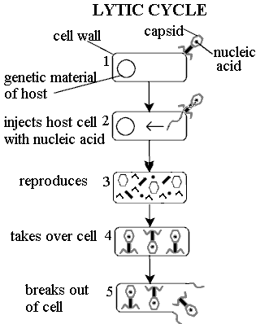
The Lysogenic Cycle:
The Lysogenic Cycle is slightly different. After the virus's nucleic acid is injected into cell, the nucleic acid becomes part of the host cell's genetic material, but is dormant; the virus does not destroy the cell. The host cell carries the nucleic acid around, reproduces, and lives normally. Eventually, the virus comes out of its dormancy, forms new viruses inside the cell, and they burst out, killing the cell. Since the cell was able to reproduce before bursting, all the new cells that were produced are already infected with the viral nucleic acid and will go through lysogeny as well. The following is an illustration of the lysogenic cycle. Examples of Viruses that Infect Humans Include: Influenza (the Flu), the common cold, chicken pox, measles, HIV/AIDS, and Hepatitis A, B, & C.
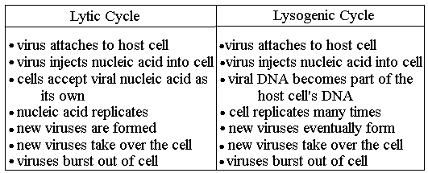
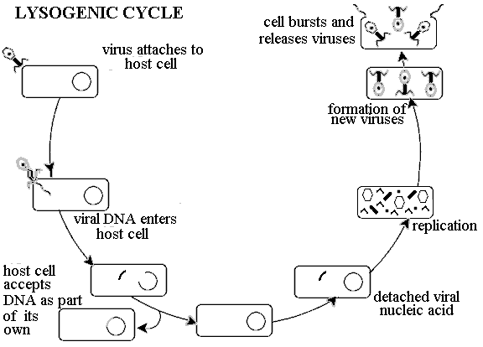
Review: Disease and Impact on Immune System & Micro-Organisms~ Since this is for review, vocabulary terms are bolded for your convenience!
The three main types of disease-causing pathogens are as follows: those caused by bacteria, by fungi, and by viruses. A person can contract a bacterial, fungal, or viral disease through direct contact with harmful bacteria, fungi, or viruses, and sometimes through inhalation. It is difficult to distinguish among the three types of diseases based on their symptoms. This is because each type can have a variety of symptoms, or they can have similar symptoms.
Bacteria are single-celled organisms containing genetic material, but having no true nucleus. A nucleus is the part of a cell that contains the genetic material in most cells and controls a cell's activities. When bacteria enter a cell, they either destroy the cell or produce harmful chemicals inside it. Some diseases caused by bacteria include strep throat, pneumonia, meningitis, tuberculosis, tetanus, and cholera. Antibiotics are medicines used to stop the growth of bacteria cells.
Fungi are organisms that obtain food by absorbing nutrients from their surroundings. Fungi usually stay on the surface of the skin and appear as rashes, but they can infect internal organs as well. After the spores (seed-like capsules used for reproduction) of a fungus enter the body, the fungus begins to grow, infecting or damaging the surrounding tissue. Some examples of fungal diseases are athlete's foot, ringworm, and nail fungus. Fungal infections can sometimes go away without any treatment when the immune system is able to combat the infection on its own. Most fungal infections can be treated with anti-fungal creams and medications.
Viruses are cells that need a living host cell to reproduce. After a person comes in contact with a virus, the virus enters a cell and may either disturb the cell's activities or reproduce and kill the cell, resulting in the virus spreading to new cells. If the virus is not destroyed, it can continue to replicate and re-infect the person. Many years after being infected by a virus, the person may experience symptoms of the virus again. Common viruses include influenza (the flu), chicken pox, measles, the West Nile virus, and rabies.
Many viruses are prevented with vaccines. Vaccines contain weakened or dead forms of the virus that stimulate the immune system to build up chemicals called antibodies to fight off the virus if the person should come in contact with it. Vaccines are given orally or by injection. To combat infectious diseases, a healthy immune system locates bacteria, viruses, or fungi and tries to kill them. Antibodies work with white blood cells to destroy these foreign substances. Often, this causes a collection of pus and swelling in the area of infection or other symptoms, such as fever. Once antibodies are released, they stay in the body. The immune system will be able to fight off the same disease more easily if contracted in the future because more antibodies can be produced.

Nervous System – A
The nervous system controls all of the body's actions and responses & consists of nerves, the brain, and the spinal cord. Nerves are bundles of neurons, the cells of the nervous system that carry electrical impulses. An impulse is an electric signal that is sent through the nervous system so that the body can respond to a stimulus. A stimulus is an action or condition that creates a response.
The nervous system can be divided into two major categories:
- Central nervous system (CNS) consists of the brain and spinal cord
- Peripheral nervous system (PNS) consists of all the nerves that extend outside of the central nervous system.
The portion of the PNS that controls all of the involuntary actions of the human body, such as the beating of the heart and reflexes, is the autonomic nervous system. Reflexes are involuntary responses to stimuli. An example of a reflex is when your hand automatically pulls back from a hot object that was touched. The cell body is the main part of the nerve cell and contains the nucleus. The axon and dendrites are extensions of the nerve cell that conduct impulses. Finally, the gap between neurons is called the synapse.
The following diagram shows the major parts of the brain:
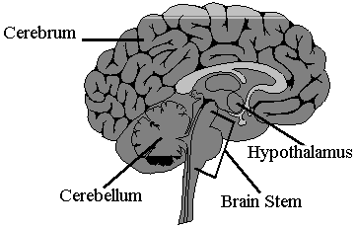
The following diagram shows the four basic parts of a neuron:
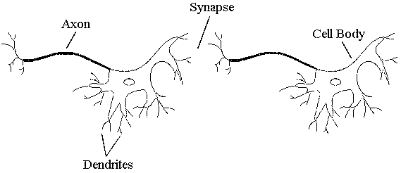
Nervous System – B:
The main parts of the brain are:
Cerebrum: is the largest part of the brain and controls voluntary muscle movement, thought, memory, emotion, and the senses.
Cerebellum: is located in the back of the brain and controls muscle coordination and balance.
Hypothalamus: is located in the center of the brain and regulates appetite, body temperature, and controls hormones.
Brain Stem: connects the brain to the spinal cord and contains the medulla oblongata. Medulla Oblongata: controls involuntary functions, such as breathing and heartbeat.
This diagram shows the locations of the main parts of the brain:
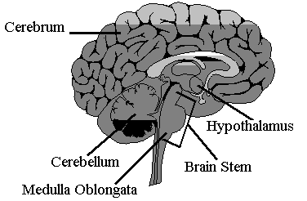
The nervous system can be divided into two parts. The central nervous system (CNS) consists of the brain and spinal cord, and the peripheral nervous system (PNS) consists of all the nerves that are outside of the central nervous system. Nerves are bundles of neurons, or cells of the nervous system, that act like wires carrying impulses. An impulse is an electric signal that is sent through the central and peripheral nervous system so the body can respond to stimuli.
In the nervous system, there are three types of neurons. Sensory neurons carry impulses towards the CNS, motor neurons carry impulses away from the CNS, and inter-neurons (sometimes called association neurons) connect other neurons and process the information within the CNS. Impulses enter neurons, move through their ends, called dendrites, and travel towards the cell body. From the cell body they enter the axon and move away from the cell body. Then the impulse leaves through the ends of the axon and jumps through the synapse, which is the gap between neurons, to the next neuron's dendrites.
The following diagram illustrates the pathway of an impulse and the main parts of a neuron.
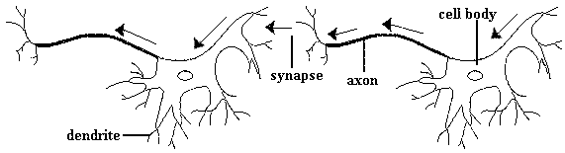
Impulses are able to travel through nerves due to a process called the sodium potassium pump. This process moves positively charged sodium (Na+) and potassium (K+) atoms across the membrane of the neuron. The neuron becomes positively charged on the outside and negatively charged on the inside. When the neuron is stimulated, the charges reverse as the impulse travels from neuron to neuron.

This diagram shows the Sodium-Potassium Pump in Action!
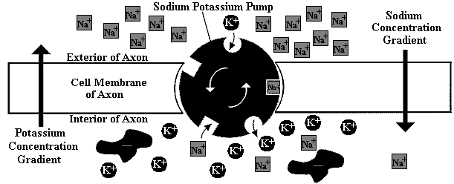
The response that occurs when you touch a hot object is a good example of how an impulse travels through all the parts of the nervous system. First, you touch the hot object and an electrical impulse is sent into the sensory neurons in your hand. The sensory neurons carry the impulse to the spinal nerves and into the spinal cord. The inter-neurons in the spinal cord take the impulse to the brain where it processes the information. An impulse is sent back to the spinal cord, out the spinal nerves, and to your muscles via motor neurons. This impulse makes your muscles contract and you pull your hand away. The whole process occurs in less than a second!
The spinal cord is a very important part of the nervous system because it sends impulses from all parts of the body to the brain. The body of the spinal cord contains white matter, which consists of axons that carry impulses, and gray matter, which contains inter-neurons. The root, root ganglion, and spinal nerve connect the spinal cord to nerves throughout the body.

The main parts of the spinal cord are shown & labeled here:
