Name: ___________________________
Date: _____________________________

Earth Science Handout: Photosynthesis & Respiration
Vocabulary in this section includes:
Photosynthesis:
Respiration:
Cellular Respiration:
Chlorophyll:
Light Reactions:
Dark Reactions:
Chloroplasts:
Electrons:
Calvin Cycle:
ATP:
Autotrophs:
Heterotrophs:
Mitochondria:

Photosynthesis and respiration are processes that all living things depend on for survival. Students should understand the basic processes and chemical reactions of respiration and photosynthesis, the relationship between these two reactions, and the similarities and differences between photosynthesis and cellular respiration.
Cellular respiration is a process that converts stored energy in glucose, a sugar, into useable energy for cells. All organisms undergo cellular respiration to obtain useable energy so that their cells can function. Organisms obtain glucose in different ways. Animals get glucose from eating food, whereas plants make glucose using a process called photosynthesis, which is explained later in this study guide. In respiration, glucose is broken down with oxygen from the air to produce carbon dioxide, water, and release energy. The energy released is in the form of a molecule called ATP. The chemical equation for cellular respiration is as follow: 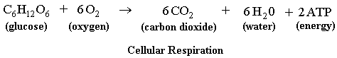
Photosynthesis is the process in which plants use sunlight and carbon dioxide to produce glucose. This process is important because it not only provides plants with the sugar they need to grow, but it also produces oxygen that animals need for cellular respiration. The reactants, or materials that are needed for this process to begin, are water and carbon dioxide. During photosynthesis, sunlight hits the leaf of a plant and enters the cells. The plant cells contain a green pigment called chlorophyll, which gives plants a green color. Chlorophyll captures the energy in sunlight to help convert water and carbon dioxide into glucose and oxygen. The glucose is stored in the plant and can be used for respiration while the oxygen is released into the air.
Photosynthesis occurs in two stages, the light reactions (also called light dependent reactions), and the dark reactions (light independent reactions). The light reactions require light energy and dark reactions do not.
The light reactions begin with light energy from the sun being absorbed into the chloroplasts. Chloroplasts are structures inside of plant cells that contain chlorophyll and are where photosynthesis occurs. The energy from the sun excites the electrons in the chlorophyll. Electrons are negatively charged particles in atoms. Excited electrons are electrons with extra energy. The excited electrons cannot keep the excess energy, so they undergo a process to get rid of the energy. Another reaction that takes place during the light reactions is the splitting of water molecules. A water molecule is composed of two hydrogen atoms and one oxygen atom. Water molecules present in the leaf cells separate into hydrogen and oxygen. The oxygen atoms are released into the air as a waste product of photosynthesis.
The dark reactions of photosynthesis do not require sunlight. During the Calvin Cycle, carbon dioxide in the air is absorbed by cells in the leaves and forms a compound which is converted through a series of chemical reactions to produce glucose (sugar). Plants use glucose for energy. The following is an illustration of the light and dark reactions of photosynthesis.
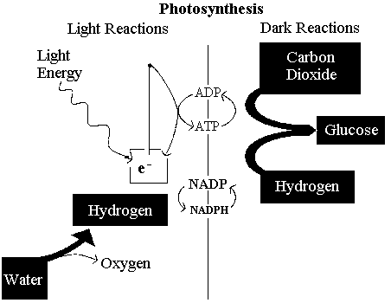
There are many similarities between photosynthesis and respiration. They are both important processes that produce ATP, they both use the electron transport chain, and they are both are part of the ongoing cycle between plants and animals.
There are, however, three main differences between photosynthesis and aerobic respiration. First, the products of one reaction are the reactants of the other. The water and carbon dioxide created during cellular respiration are used in photosynthesis. The glucose and oxygen created during photosynthesis are used in cellular respiration. As shown in the following diagram, their equations are reversed:
Secondly, not all organisms undergo both processes. All organisms undergo cellular respiration, but only autotrophs undergo photosynthesis. Autotrophs are organisms that can make their own food, like plants. Heterotrophs cannot make their own food; they must obtain energy from an outside source by eating. Thirdly, the location where the two processes occur in the cell are different. Photosynthesis occurs in the chloroplasts, while cellular respiration occurs in the mitochondria.

