Name: __________________________________
Date: ____________________________
Biology A & B: Genetics, Cell Division & Genetic Engineering
Genetics
Vocabulary for this section includes:
Traits:
Dominant:
Recessive:
Linked Genes:
Co-Dominance:
Punnett Square:
Genotype:
Phenotype:
Di-Hybrid Cross:
Allele:
Polygenic Trait:
Incomplete Dominance:
Linked Genes:
Sex-Linked Genes:

Individual inherited characteristics, or traits, may be dominant or recessive. In most cases, dominant traits are expressed if they are present and recessive traits are only expressed if the dominant trait is not present. Capital letters are used to express dominant traits and lowercase letters are used for recessive traits. These letters are called alleles. For example, if you are looking at the gene for the ability to roll your tongue, an "R" may represent the dominant trait of the ability to roll your tongue and an "r" would represent the recessive trait of not being able to roll your tongue. An individual will have a pair of these alleles such as Rr, RR, or rr, representing his or her genotype (actual genes that an individual has in their genetic code).
If the genotype has a dominant allele in it, the individual will express the dominant form of the trait. People with a genotype of Rr or RR will be able to roll their tongue. If only recessive alleles are present, the trait is recessive. A person with a genotype of rr will not be able to roll his or her tongue. The actual trait or characteristic that is expressed (visible features) is called the phenotype.
Alleles and genotypes are used to find the probability that an offspring will express a certain trait. They are placed in a chart called a Punnet square. The alleles on the outside of the following Punnet square are from the parents' genotypes for tongue rolling and the four different genotypes on the inside represent the possible genotypic combinations for each offspring. The top of the Punnet square is labeled with one parent's genotype, and the side is labeled with the other parent's genotype. In the top left square, the "R" from the mother and the first "R" from the father combine to form RR. The top right square is RR because the "R" from the mother and the second "R" from the father combine. The bottom left square is Rr because the "r" from the mother and the first "R" from the father combine. The bottom right square is Rr because the "r" from the mother and the second "R" from the father combine.
When the alleles for a single trait are the same, as in RR or rr, it is said to be homozygous. When the alleles are different, Rr for example, it is heterozygous. In the following Punnet square, the probability of having offspring with a homozygous genotype of RR is 50% and having offspring with the heterozygous genotype of Rr is also 50%, though all four genotypes will show the same dominant phenotype. In other words, all offspring will be able to roll their tongues.
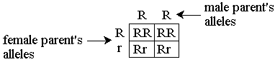
Usually, each trait in a specific gene is controlled by one allele that is dominant over another. This is not always the case. Co-dominance is when two alleles in a genotype are both fully expressed in the phenotype and show no dominance over each other. An example of co-dominance is a blood type of AB. Both the "A" allele and the "B" allele are equally dominant so both are fully expressed. Incomplete dominance is when two alleles mix to form a phenotype that is a combination of the two traits. Certain plants that have an allele for white flowers and an allele for red flowers will create pink flowers. Some traits are controlled by interactions between more than one pair of genes. These are called polygenic traits and may occur in traits like skin color. Skin color in humans is determined by five separate genes, with two alleles each. A person can have many different combinations of these alleles resulting in various skin colors.
Linked genes are located on the same chromosome, so they will be inherited together. Sex-linked genes are carried on the X or Y chromosomes, which are the chromosomes that determine sex. Colorblindness is a sex-linked trait. It is much more common for males to be colorblind because the gene for that trait, which is recessive, is carried on the X chromosome. Women have two X chromosomes, so if they carry the colorblindness gene on one X chromosome, it could be masked by the other X chromosome. Men only have one X chromosome, so if they carry the gene, there is nothing to mask it. For instance, blood type is an example of co-dominance and colorblindness is an example of a sex-linked trait.
Since organisms have more than one trait, a di-hybrid cross is used to predict different combinations of genotypes. A di-hybrid cross works like a simple Punnet square, but contains a larger chart. The alleles for seed texture and color in pea plants are as follows:
R = round seed
r = wrinkled seed
Y = yellow seed
y = green seed
The following is an example of a di-hybrid cross for seed color and texture in pea plants:
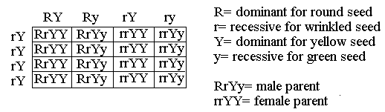
The male parent has a genotype of RrYy. One allele is for texture, one is for color, and there are only four combinations of the allele pairs. The headings on the chart break this genotype into RY, Ry, rY, and ry. For the female parent with a genotype of rrYY, the four combinations are rY. The allele pairs on the outside of the squares are combined in each square to make a four-allele genotype. The male parent is heterozygous for round, yellow seeds and the female is homozygous for wrinkled, yellow seeds. The probability of an offspring with a genotype of RrYY is 4/16 (or 1/4) because there are four of these genotypes out of the 16 possibilities or squares. There is a 8/16 (or 1/8) chance of having a wrinkled yellow seed offspring. They have a genotype of rrYY or rrYy.
Example: Using a di-hybrid cross, find the probability of beetles having an offspring with red eyes and long wings. Red eyes are dominant, black eyes are recessive, long wings are dominant and short wings are recessive. The male parent, with red eyes and long wings, has a genotype of RrLl. The female parent, with red eyes and short wings, has a genotype of Rrll. Answer: 6:16 (or 3:8).
The genotypes that will produce a beetle with red eyes and long wings are RRLL, RrLl, RRLl, and RrLL. As you can see in the following di-hybrid cross, the genotypes RRLl and RrLl show up 6 times out of 16 possible squares. So the probability is 6:16 (or 3:8).
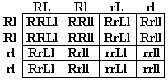

Cell Division: Meiosis & Mitosis
Vocabulary for this section:
Mitosis:
Meiosis 1 & 2:

Genes:
Chromosomes:
Prophase:
Metaphase:
Anaphase:
Telophase:
Centrioles:
Cytokinesis:

There are two cell division processes, mitosis and meiosis, where cells divide to

There are two cell division processes, mitosis and meiosis, where cells divide to produce more cells. To understand these processes, it is important to understand genes and chromosomes. Genes control heredity, the transfer of characteristics from parents to offspring, and determine the traits that will be expressed. Genes link together to form chromosomes. Chromosomes are structures that carry genes and come in pairs.
Mitosis is a form of asexual reproduction that is needed for the growth and repair of cells. It is a process by which a cell divides and passes on copies of its DNA to its daughter cells. The daughter cells are identical copies of the parent cell. Genetic material in the nucleus, a structure in the center of cells, must duplicate before the process begins. The four subsequent phases of mitosis are described here.
1. Prophase - Chromosomes shorten and become visible, then the nuclear membrane (the layer on the outside of the nucleus) begins to deteriorate. Long filaments that aid the movement of the chromosomes, called spindle fibers, appear. Also, small structures called centrioles move toward the opposite sides of the nucleus.
2. Metaphase - The chromosomes line up in the center of the cell. At this point, spindle fibers attach to the center of each chromosome.
3. Anaphase - The chromosomes separate in half, are pulled away from the center, and move to the opposite ends of the cell.
4. Telophase - The chromosomes lengthen, each group reaches one of the centrioles, and the spindle fibers disintegrate. Finally, the cell undergoes cytokinesis where the cell cleaves (divides), the cytoplasm (a thick jelly-like substance inside cells) splits in two, and two daughter cells are formed.
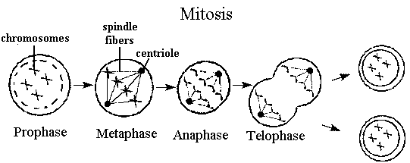
Meiosis is the process that produces sex cells. Unlike mitosis, the cells produced are not identical and contain only half the number of chromosomes as the original cell. Before meiosis begins, the genetic material in the cell must replicate. Meiosis occurs in two stages where two separate cell divisions occur. These two stages are called meiosis I and meiosis II. Each phase is similar to the phases of mitosis but are numbered with a I or II, depending when they occur. These phases are described here.
1. Prophase I - Chromosomes shorten and become visible, the nuclear membrane deteriorates, and spindle fibers appear. Chromosomes that are similar, called homologous chromosomes, pair up next to each other. Homologous chromosomes entangle so that their genes can be mixed in a process called cross over.
2. Metaphase I - The homologous chromosomes line up along the center of the cell and spindle fibers attach to them.
3. Anaphase I - The homologous chromosomes separate. These chromosomes move towards opposite sides of the cell.
4. Telophase I - In the final phase of meiosis I, the cell divides into two cells. Each of the two cells has one double stranded chromosome from each of the homologous chromosome pairs.
Before meiosis II begins, the chromosomes do not replicate. Each of the cells produced from meiosis I will divide from this point in prophase II, metaphase II, anaphase II, and telophase II. The processes in these final four phases are the same as in mitosis, though in meiosis, four different sex cells are formed from the one original cell.
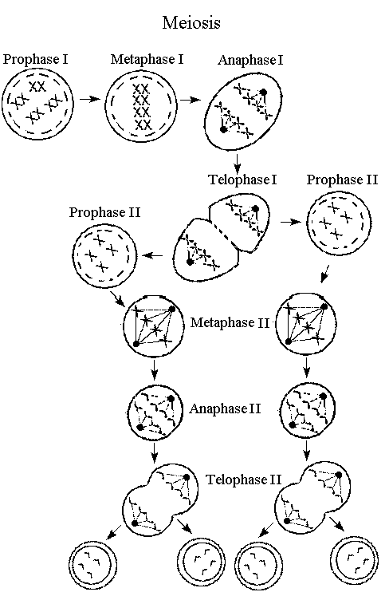
Genetic Engineering
Selective Breeding:
Gene Splicing:
Cloning:
Vegetative Propagation:

The goal of genetic engineering is to alter an organism's genetic material to produce an organism with more desirable traits. There are several methods of genetic engineering. Students will be able to identify various methods of genetic engineering and their uses.
Selective breeding is one example of genetic engineering. There are a few methods and reasons to selectively breed organisms. One method involves mating the same breed to ensure a pure breed. If a species of flower is red, but sometimes produces white flower offspring, the parent plant and its red flower offspring could be bred with another red flower of the same species to eventually produce a flower that only has red offspring. Another technique involves mating different breeds to produce a particular type of organism with the traits of two or more different breeds. If a pet owner wants to have a fast dog with curly fur, selective breeding can be used. A fast dog like a Greyhound can be bred with a curly-haired dog like a Standard Poodle to produce the desired dog.
Gene splicing is a method of genetic engineering in which portions of an organism's genetic material are cut into pieces and recombined with portions of genetic material from other organisms. This method can be used to prevent diseases by adding specific sections of genetic material into an organism that will help the organism to fight the disease. For example, if a person's body is unable to produce a certain disease fighting chemical, gene splicing may be used to allow some cells of that person's body to begin producing that chemical.
Cloning is another form of genetic engineering in which the genetic material from one organism is placed into the cell of another organism, which has had the genetic information removed. This can create another cell or organism that is genetically identical to the original cell or organism. One use for this form of genetic engineering can be to produce disease resistant strains of plants. The plants that are currently naturally disease resistant can be replicated through cloning to create new plants that are disease resistant.
Finally, vegetative propagation is another method used to genetically engineer plants. It allows the production of a complete organism from a portion of an existing organism. For example, the stem of a Pothos plant can be cut and, if planted, the cutting will grow into a new plant. Genetic engineering occurs when the cut portion of a plant is bound to the cut portion of a different type of plant and they eventually grow together as one plant. If a plant is unable to reproduce, vegetative propagation would be a way to create additional plants from the parent plant.

